# Class14. More Workflow Example Purchase Order

**Ex1.**

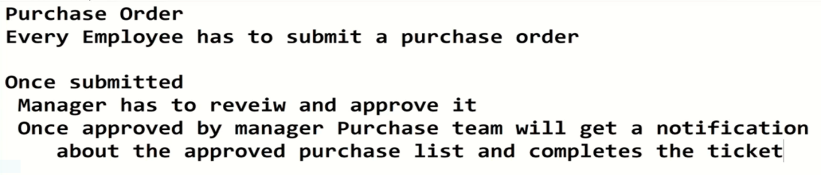

* 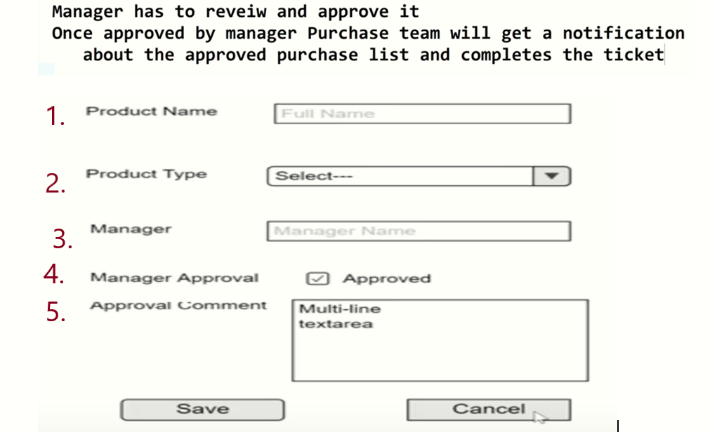

**First Section: Creating Form**

**Create custom List For purchasing order**

Setting => site setting => add an app =>Custom List =>Name(PurchaseOrder) then create

**Create Column**: Look the above form to create the column

1.**Title** = Product Name

Site content => ellipse next to PurchaseOrder =>Setting =>Title => Name(Product Name) => create

And Create other columns:

2. **Product Type**: Create => Purchase Type => Choice =>Required this column(yes) =>{Stationary,

Computer, foods} => default empty => Ok

3**. Manager**: Create => Manager => Person/group => Required this column(yes) => ok

4. **Manager Approval**: Create => Approved =>yes/no =>default(No) =>Ok

5. Approval comment: Create => Approval comment => multi line of text => plain text =>Ok

Then we get

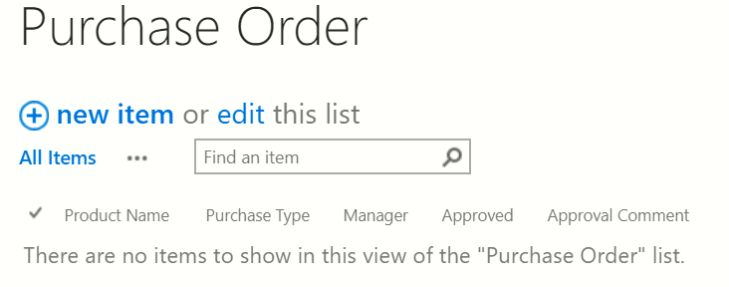

**If we click** we get the following form

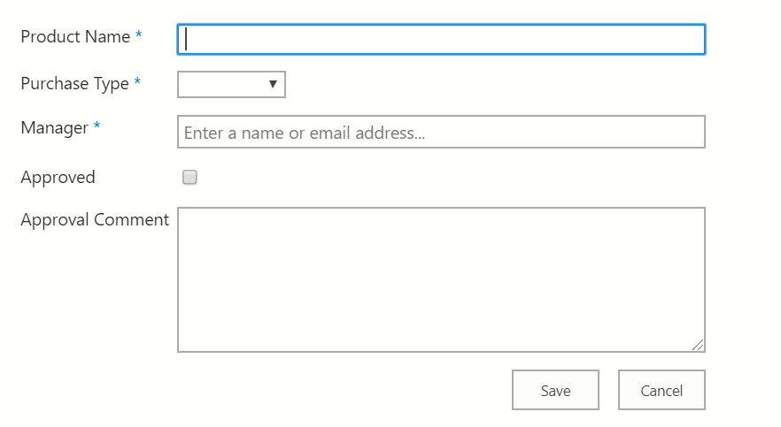

This Form should be submitted for Manager. But the last two rows shouldn’t be visible for purchasers those are for only Manager so that.

**We have to hide them from purchaser**

**List => List Setting => Advanced Setting =>Content Type (Yes) =OK**

**And then**

**List => List Setting =>Item =>Approved =>Hide**

**Second Section: Modify the form in SPD**

**Open SPD**: List =>Edit List =>open =>yes

**Test it**

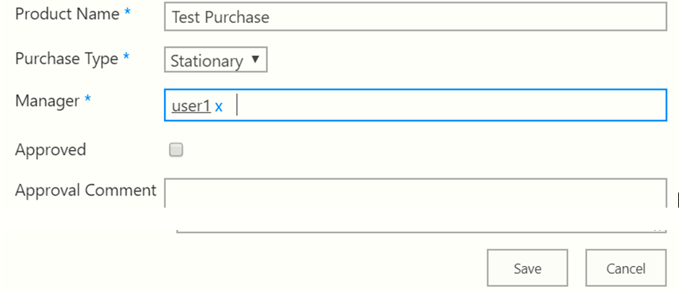

We can modified it: Ellipse => Edit

Create Workflow:

New next to Workflow/List workflow at the top =>

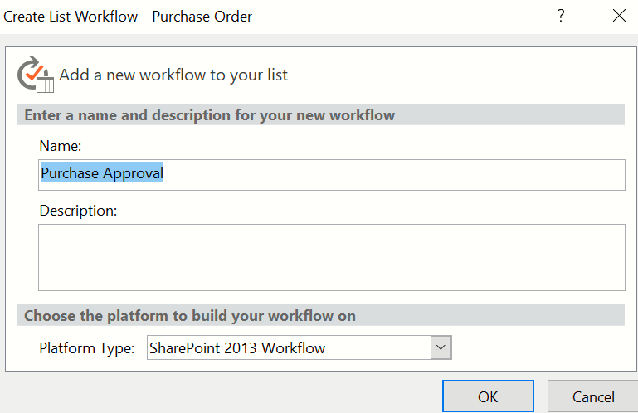

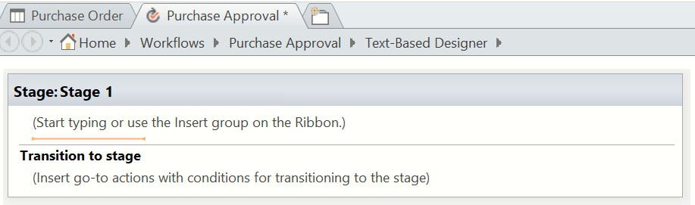By clicking purchase Approval

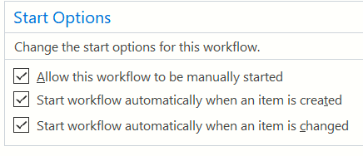

**How do we now our item is modified**

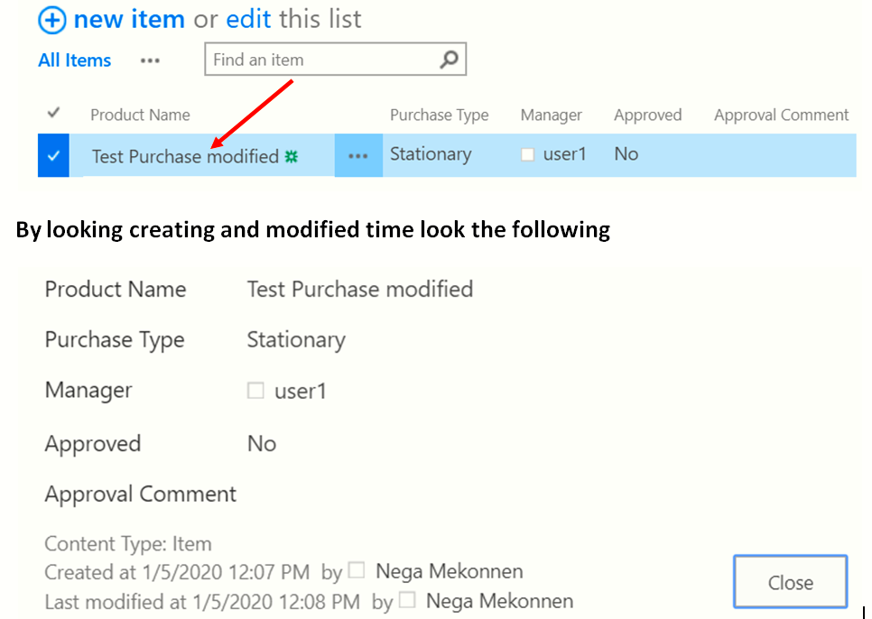

**Go to SPD**

